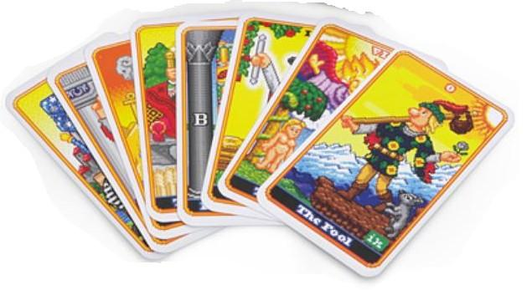
Serenity Paws Animal Rescue
Fundraising Event
Sunday, March 19th ~ 12:00 to 4:00p
At the Oakland First Aid Squad, 285 Ramapo Valley Rd. Oakland, NJ 07436
For more information please call: Jill at 201-956-1281

Bios for Healer & Readers

Yvette McGuire ~ Chakra Tune-ups
“Life’s too short to live out of Tune”

I am a Certified Vibrational Sound Master Teacher/P3 for SomaEnergetics, which uses a powerful series of Vibrational Sound techniques that utilize tuning forks tuned to the frequencies of the Ancient Solfeggio as well as other forks such as Brain tuners and DNA Tuners.
This exciting sound modality is a great way to access our subtle energy bodies and free blocked energy, creating openings for personal transformation and healing! The Ancient Solfeggio frequencies facilitate a sense of balance and harmony and reconnect you with your inner energy potential.

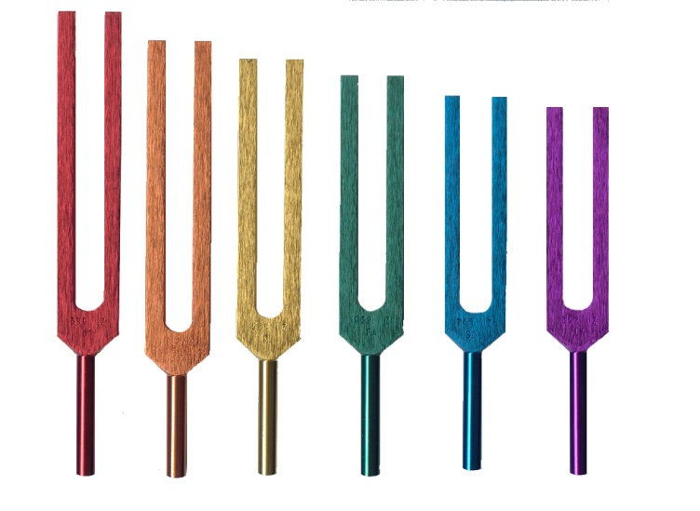

* * * * * * *

Marissa Dolan~ Psychic Tarot Readings

Our Guest reader for today has been using her gift as an Intuitive Tarot Reader for 10 years. She also has the ability of physical/emotional empath and specializes in matters of the heart. Marissa delivers life enhancing readings with compassion and soul felt guidance. Those who have had readings from Marissa leave feeling lighter, hopeful and optimistic!

Yasmina Groves ~ Psychic Palm Readings or Mediumship

Yasmina is a psychic palmist and Medium who has been doing psychic readings for twenty one years. Using the hand as her tool, she conducts her readings from a place of love and healing. She uses her psychic ability to guide, answer questions, provide healing, and confirm any situation that one may find themselves in
on their journey.

Yasmina has been a member of the Metaphysical Center of NJ for over twenty nine years. She is a
graduate of the twelve semester course the center offers on Metaphysics and Parapsychology.

Dev Markowitz ~ Psychic Tarot Readings

Dev is an intuitive tarot reader and Reiki practitioner; she has been reading the tarot since childhood. Tarot is her tool to connect to the spiritual realm allowing her to look objectively into situations to provide clarity. Her goal is to guide her clients down their right path, empower them to make decisions in challenging situations, and make the changes necessary to improve their lives. Her readings provide insight to help people overcome life's obstacles and realize their full potential. She believes that all things can be achieved through faith, gratitude, and optimism.

Donna Marie ~ Mediumship / Psychic Tarot Readings

Donna Offers mediumship readings as well as Tarot card readings. She has been sharing her Psychic gifts for over 41 years. You will find her readings address the energy surrounding an issue and what one may do to bring balance and harmony to resolve it.

Shannon Wisener ~ Psychic Tarot Readings

I have been following my Spiritual path for many years. My passion in life is to help animals and people. I provide clarity by interpreting tarot cards to assist you on your spiritual journey. A drop of insight can make all the difference in the ocean of your life. May my readings give you the guidance and peace you deserve.

The above participants provided through Mystical World, LLC ~ Lyndhurst, NJ ~ 201-896-3999
* * * Readings for Entertainment Only * * *

